Join i Union

Inner Join

[SELECT](http://localhost/phpmyadmin/url.php?url=https://dev.mysql.com/doc/refman/5.5/en/select.html) orderNumber, orderDate, orderLineNumber, priceEach FROM orders INNER JOIN orderdetails USING (orderNumber) ORDER BY orderNumber DESC

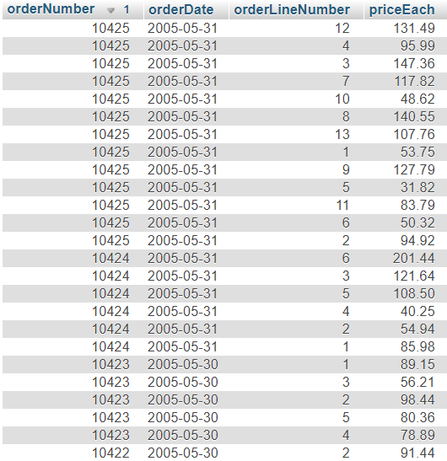

Left Join

[SELECT](http://localhost/phpmyadmin/url.php?url=https://dev.mysql.com/doc/refman/5.5/en/select.html) customerNumber, customerName, orderNumber, status, city FROM customers [LEFT](http://localhost/phpmyadmin/url.php?url=https://dev.mysql.com/doc/refman/5.5/en/string-functions.html#function_left) JOIN orders USING (customerNumber) WHERE orderNumber [IS](http://localhost/phpmyadmin/url.php?url=https://dev.mysql.com/doc/refman/5.5/en/comparison-operators.html#operator_is) NULL

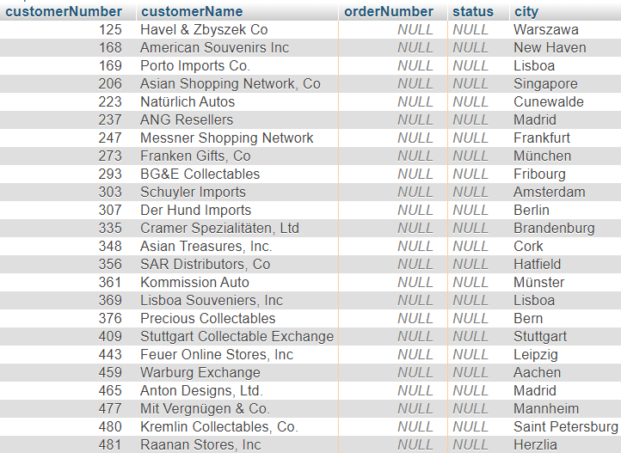

Right Join

[SELECT](http://localhost/phpmyadmin/url.php?url=https://dev.mysql.com/doc/refman/5.5/en/select.html) employeeNumber, customerNumber, country FROM customers [RIGHT](http://localhost/phpmyadmin/url.php?url=https://dev.mysql.com/doc/refman/5.5/en/string-functions.html#function_right) JOIN employees ON salesRepEmployeeNumber = employeeNumber GROUP BY employeeNumber

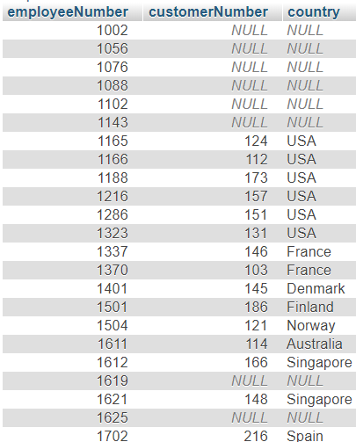

Cross Join

[SELECT](http://localhost/phpmyadmin/url.php?url=https://dev.mysql.com/doc/refman/5.5/en/select.html) orderDate, orderNumber, status FROM orders AS a CROSS JOIN products AS b

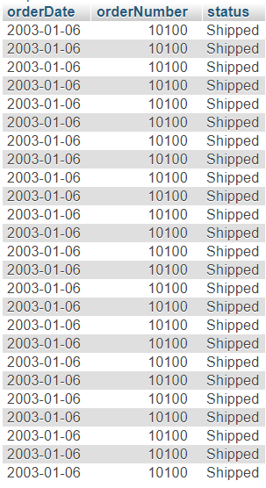

Self Join

[SELECT](http://localhost/phpmyadmin/url.php?url=https://dev.mysql.com/doc/refman/5.5/en/select.html) CONCAT(m.lastName, ', ', m.firstName) AS Manager, CONCAT(e.lastName, ', ', e.firstName) AS 'Direct report' FROM employees e INNER JOIN employees m ON m.employeeNumber = e.reportsTo GROUP BY Manager DESC

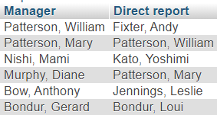

Union

[SELECT](http://localhost/phpmyadmin/url.php?url=https://dev.mysql.com/doc/refman/5.5/en/select.html) CONCAT(city,' ',country) 'city and country' FROM customers UNION [SELECT](http://localhost/phpmyadmin/url.php?url=https://dev.mysql.com/doc/refman/5.5/en/select.html) CONCAT(city,' ',country) FROM offices

